Microeconomics 3.2
SSEMI2 Explain how the law of demand, the law of supply, and prices work to determine production and distribution in a market economy.
e. Identify the determinants (shifters) of supply (e.g., changes in costs of productive resources, government regulations, number of sellers, producer expectations, technology, and education) and illustrate the effects on a supply and demand graph.
The determinants of supply describe the types of changes in a market that will cause the entire supply curve to move to the right or to the left. In other words, all sellers of a good, service, or productive resource will be willing and able to supply more or less of their product at all prices in the market. The shift will cause a change in the equilibrium price and equilibrium quantity in the market.

- Change in the costs of productive resources (INPUT COST) | Effects of a Change in Supply on a Supply and Demand Curve
Decrease in costs - If the resources needed to produce a product become more less expensive, sellers will produce more and supply will increase and shift to the right.  Example: If the cost of electricity used to power an automotive factories falls, the supply of cars in the market increases. | 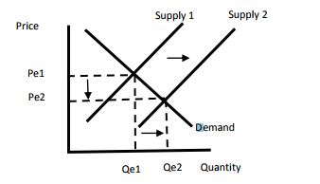
Increase in costs – If the resources needed to produce a product become more expensive, sellers can produce less and supply will decrease and shift to the right.  Example: If the price of peanuts rises, then the cost of making peanut butter will increase causing the supply of peanut butter to decrease. | 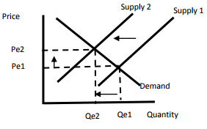

- Changes in Government Regulations | Effects of a Change in Supply on a Supply and Demand Curve

Decrease in Regulations - If the government decreases the regulations on sellers in a market, sellers will produce more of the product and supply will shift to the right.

Example: When the U.S. stopped controlling the fares and routes for air travel in 1978, airlines made decisions based on market factors, increasing the supply of flights and the price of air travel fell.

Increase in Regulations - If the government increases the regulations on sellers in a market, sellers will produce less of the product and supply will shift to the left.

Example: If the government requires factories to reduce pollution, complying will initially increase costs of production in the market and reduce supply.

- Change in Number of Sellers | Effects of a Change in Supply on a Supply and Demand Curve

Decrease in the Number of Sellers - If the number of sellers in the market decreases, there will be fewer producers of the product, supply will decrease and shift to the left.

Example: As the demand for DVDs decreased due to consumer preference for streaming movies, the market price for DVDs fell. This lower market price caused sellers to leave the DVD market and supply decreased.

Increase in the Number of Sellers - If the number of sellers in the market increases, there will be more producers of the product, supply will increase and shift to the right.

Example: The demand for pecans from people in China has increased which has increased the market price for pecans. This increased market price has attracted more farmers into the pecan market. As trees become productive, the supply of pecans will increase.

- Change in Producer Expectations | Effects of a Change in Supply on a Supply and Demand Curve

Producers expect the price of their product to fall in the future - If producers expect the price of their product to fall in the future, they will supply more in the present while the market price is higher. This will cause supply to increase and shift to the right.

Example: If airlines expect prices for airline tickets to fall in September when families are less likely to travel due the school calendar, they will supply more during the summer months when they can charge higher fares

Producers expect the price of their product to rise in the future - If producers expect the price of their product to rise in the future, they will supply less in the present and wait for the price to rise. This will cause supply to decrease and shift to the left.

Example: If producers expect consumers to be willing to pay a higher price for candy during holidays like Halloween, they will supply less now and put their efforts into producing for the period preceding the holiday when the price is higher.

- Change in Technology | Effects of a Change in Supply on a Supply and Demand Curve
Production Technology used to produce a product improves - If producers implement new, more efficient technology in the production process, supply will increase and shift to the right.

Examples: When auto manufacturer were able to implement robotics on the production line, automobiles were produced more quickly and at a smaller cost per unit. This allowed the industry to supply more cars.
Production Technology, used to produce a product, declines – This scenario is unusual. This could occur if a natural or cyber disaster destroyed access to production technology for a large number of the market’s producers at one time or if a defect in production technology affects many producers all at one time. If producers lose the benefits of production technology, supply decreases and shifts to the left.

Example: If a cyberattack interfered with the GPS on which farmers rely to monitor and service their fields for a significant amount of time.

- Change in Education | Effects of a Change in Supply on a Supply and Demand Curve
Education of the workers in a market declines - If the education, knowledge, and skills of many workers in a market declines, their labor productivity will decrease. As a result supply will decrease and shift to the left.

Example: An economic boom allows skilled workers to move from fast food jobs into white collar office administration jobs. Fast food producers are forced to hire less skilled workers and supply of fast food decreases.

Education of the workers in a market improves - If many workers in a market improve their education, knowledge, and skills related to the production process, their labor productivity will increase. As a result supply will increase and shift to the right.

Example: Workers train on a new software package that will increase. productivity in the market and allow supply to increase

f. Identify the determinants (shifters) of demand (e.g., changes in related goods, income, consumer expectations, preferences/tastes, and number of consumers) and illustrate the effects on a supply and demand graph.
The determinants of demand describe the types of changes in a market that will cause the entire demand curve to move to the right or to the left. In other words, all consumers of a good, service, or productive resource will be willing and able to purchase more or less of a product at all prices in the market. The shift will cause a change in the equilibrium price and equilibrium quantity in the market.

1A. Change in Price of Related Goods (COMPLEMENTARY) | Effects of a Change in Demand on a Supply and Demand Graph
Decrease in the Price of a Complementary Good - If the price of a good, service, or resource that is consumed with the product in this market falls, then the demand for the product in this market will rise and shift to the right.  Example: When the price of cream cheese falls, the demand for bagels will increase. | 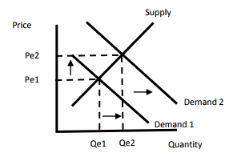
Increase in the Price of a Complementary Good - If the price of a good, service, or resource that is consumed with the product in this market rises, then the demand for the product in this market will fall and shift to the left.  Example: When the price of peanut butter increases, the demand for jelly will decrease. | 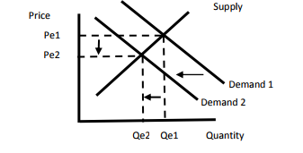

1.B Change in Price of Related Goods (SUBSTITUTES) | Effects of a Change in Demand on a Supply and Demand Graph
Increase in the Price of a Substitute Good - If the price of a good, service, or resource that is consumed in place of the product in this market rises, then the demand for the product in this market will rise and shift to the right.

Example: When the price of black bean veggie burgers rises, the demand for tofu veggie burgers will increase.
Decrease in the Price of a Substitute Good - If the price of a good, service, or resource that is consumed in place of the product in this market decreases, then the demand for the product in this market will fall and shift to the left.

Example: When the price of coffee falls, the demand for tea will decrease.

2. Change in Consumer Income | Effects of a Change in Demand on a Supply and Demand Graph
Decrease in Consumer Income - If the income of consumers in the market for a normal good falls, then the demand for the product in this market will fall and shift to the left.

Example: During an economic recession, workers may take pay cuts or lose their from a job loss. If a worker’s income falls, he or she will have less to spend on goods and services. The demand for the product will decrease.
Increase in Consumer Income – If consumers in a market for a normal good have an increase in income, then the demand for the product in this market will rise and shift to the right.

Example: If the government decides to lower income tax rates, consumers will have more disposable income to spend on goods and services and demand will increase.

3. Change in Consumer Expectation | Effects of a Change in Demand on a Supply and Demand Graph
Consumers expect the price of a product to rise in the future - If consumers expect the price of a product to rise in the future, they will demand more in the present before the price rises. This will cause demand to increase and shift to the right.

Example: If consumers expect producers to charge higher prices for candy during holidays like Halloween, some consumers will purchase candy early before prices rise for the holiday.
Consumers expect the price of a product to fall in the future - If consumers expect the price of a product to fall in the future, they will demand less in the present while the market price is higher. This will cause demand to decrease and shift to the left.

Example: If consumers expect prices for airline tickets to fall in September when families are less likely to travel due the school calendar, consumers who can travel any time will demand fewer tickets during the summer months when prices are high.

4. Change in Consumer Tastes/Preferences | Effects of a Change in Demand on a Supply and Demand Graph
Increase in Consumer Taste for a Product – If consumers in a market for a good or service have an increase in their taste for that product, then the demand for the product in this market will rise and shift to the right.

Example: If researchers publish a study concluding that eating a grapefruit every day causes people to lose weight, there will be an increase in taste for grapefruit and demand will increase.
Decrease in Consumer Taste for a Product – If consumers in a market for a good or service have a decrease taste for a product, then the demand for the product in this market will rise and shift to the right.

Example: A series of airplane crashes will decrease consumer taste for air travel and demand will decrease.

5.Change in Number of Consumers in the Market | Effects of a Change in Demand on a Supply and Demand Graph
Decrease in Consumers in the Market – If consumers leave the market for a product, then the demand for the product in this market will fall and shift to the left.

Example: As ride and room sharing apps have expanded, the number of consumers in the traditional taxi and hotel markets has decreased, decreasing demand for these services.
Increase in Consumers in the Market – If more consumers enter the market for a product, then the demand for the product in this market will rise and shift to the right.

Example: As the number of Americans connected to the internet has risen, the number of consumers in the market for online retail has increased and demand has increased.

g. Explain and illustrate on a graph how prices set too high (e.g., price floors) create surpluses, and prices set too low (e.g., price ceilings) create shortages.

In some limited circumstances, governments or producers will choose to set a market price rather than allow the forces of supply and demand to determine the market price. A government may set a price floor or price ceiling on a good or service. A price floor sets a minimum price for which a product can be sold. Price floors often lead to a surplus of a good. A surplus is when the supply of a product is greater than the demand for a product. An example of a price floor is a minimum wage. A price ceiling sets a maximum price at which a good can be sold. A price ceiling often leads to a shortage. A shortage is when the demand for a product is greater than the supply of a product. An example of a price ceiling would be rent control.

Price Floor | Price Ceiling
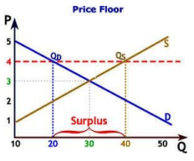 | 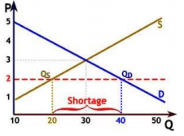
Result of Artificial Price: Supply (40) is greater than the Demand (20), this creates a Surplus of Quantity | Result of Artificial Price: Demand (40) is greater than the Supply (20), this creates a Shortage of Quantity
Example: Minimum wage is when the government sets wages above what employers are willing to pay. This creates a surplus of low paying job, because no one wants a low paying job. Even at the higher wage set by the government. | Example: Rent control housing is when the government sets the landowners rent below the market price. This creates a shortage of low rent housing, because everyone wants cheap housing.

