Unit 3 Mastery

- Which of the following best defines microeconomics?
  - Concepts and skills dealing with human behavior and choices as they relate to relatively small units – an individual, a business firm, or a single market
  - Concepts and skills dealing with human behavior and choices as they relate to the entire economy.
- Which of the following best defines macroeconomics?
  - Concepts and skills dealing with human behavior and choices as they relate to relatively small units – an individual, a business firm, or a single market
  - Concepts and skills dealing with human behavior and choices as they relate to the entire economy.
- Which of the following best explains the product market
  - Consumers spend the income they earned to buy goods and services, that earns revenue for businesses
  - People sell their land, labor, capital, and business and businesses exchange for income payments
- Which of the following best explains the factor or resource market?
  - Consumers spend the income they earned to buy goods and services, that earns revenue for businesses
  - People sell their land, labor, capital, and business and businesses exchange for income payments
- Which of the following best defines the circular flow of goods and services?
  - Shows the interactions between buyers and sellers in different markets.
  - Shows a countries balance of trade with other countries

Use the following chart to answer questions 7-10.
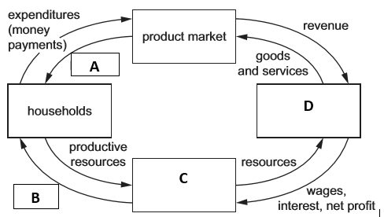
- Which of the following represents letter A?
  - Products
  - Income
- Which of the following represents letter B?
  - Products
  - Income
- Which of the following represents letter C?
  - Factor market
  - Businesses
- Which of the following represents letter D?
  - Factor market
  - Businesses
- Which of the following best defines the law of supply?
  - An economic principle stating that as price rises, the quantity a seller is willing and able to sell increases.
  - An economic principle stating that as the price of a good rises, the quantity of the good consumers are willing and able to buy decreases.

- Which of the following best defines the law of demand?
  - An economic principle stating that as price rises, the quantity a seller is willing and able to sell increases.
  - An economic principle stating that as the price of a good rises, the quantity of the good consumers are willing and able to buy decreases.
- Which of the following best explains market clearing price or equilibrium price?
  - Found at the intersection of the market demand and supply curves. It is the point at which the quantity demanded by consumers is equal to the quantity supplied by producers.
  - Found when the government creates a price ceiling or price floor.
- Which of the following best explain change in quantity demand/supply?
  - The amount of a good, service, or resource buyers/seller are willing and able to buy/sell at one specific price. Movement along the supply/demand curve.
  - A change in the supply/demand of a good or service due to a change a determinant of supply/demand. A shift in the supply/demand curve.
- Which of the following best explains change in demand/supply?
  - The amount of a good, service, or resource buyers/seller are willing and able to buy/sell at one specific price. Movement along the supply/demand curve.
  - A change in the supply/demand of a good or service due to a change a determinant of supply/demand. A shift in the supply/demand curve.
Use the following chart to answer questions 15 and 16.
Graph A | Graph B
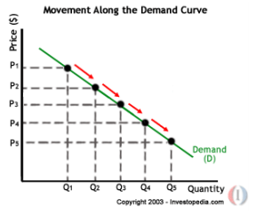 | 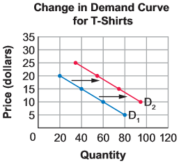

- Which of the above graphs is a change in quantity demanded?
  - Graph A
  - Graph B
- Which of the above graphs is a change in demand?
  - Graph A
  - Graph B
- Which of the following are the 6 determinants or factors that cause supply to shift?
  - Costs of productive resources, government regulations, number of sellers, producer’s expectations, technology, education.
  - Related goods, income, consumer expectations, preferences/tastes, number of consumers
- Which of the following are the 5 determinants or factors that cause demand to shift?
  - Costs of productive resources, government regulations, number of sellers, producer’s expectations, technology, education.
  - Related goods, income, consumer expectations, preferences/tastes, number of consumers
- Which of the following is an example of a complementary good?
  - Pepsi and Coke
  - Peanut Butter and jelly
- Which of the following is an example of a substitute good?
  - Pepsi and Coke
  - Peanut Butter and jelly
Use the following chart to answer questions 21-24.
Graph A | Graph B
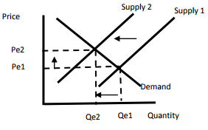 | 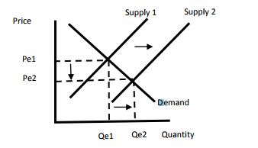
- Which of the above graphs shows an increase in quantity supplied, decrease in price, and increase in supply?
  - Graph A
  - Graph B
- Which graph shows a decrease in quantity supplied, increase in price, and decrease in supply?
  - Graph A
  - Graph B
- Which of the above graphs shows what will happen to the supply of U.S. Cars if nationwide auto workers go on strike?
  - Graph A
  - Graph B
- Which of the above graphs shows what will happen to the supply of U.S. Cars if the cost of Steel decreases?
  - Graph A
  - Graph B
Use the following chart to answer questions 25-27.
Graph A | Graph B
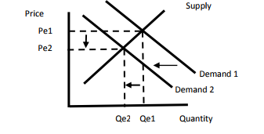 | 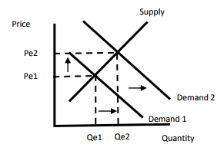
- Which of the above graphs shows what will happen to the demand for U.S. cars if consumer’s income decreases?
  - Graph A
  - Graph B
- Which of the above graphs shows what will happen to the demand for U.S. cars if the price of foreign cars increases?
  - Graph A
  - Graph B
- Which of the above graphs shows what will happen to the demand for U.S. cars if the price of gas decreases?
  - Graph A
  - Graph B
- Which of the following best explains a price floor?
  - Minimum wage, rice above the equilibrium price, sets a minimum price for which a product can be sold
  - Rent control, price below the equilibrium price, sets a maximum price at which a good can be sold.
- Which of the following best explains a price ceiling?
  - Minimum wage, price above the equilibrium price, sets a minimum price for which a product can be sold
  - Rent control, price below the equilibrium price, sets a maximum price at which a good can be sold.
- What do government price ceilings create?
  - Surplus
  - Shortage
- What do government price floors create?
  - Surplus
  - Shortage
Use the following chart to answer questions 32-33.
Graph A | Graph B
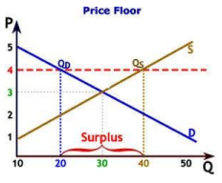 | 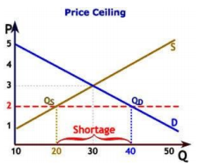

- Which the above graphs best represents a price ceiling?
  - Graph A
  - Graph B
- Which of the above graphs best represents a price floor?
  - Graph A
  - Graph B
- What are the three types of business organizations?
  - Sole proprietorship, partnership, corporation
  - Oligopoly, monopoly, monopolistic competition
- Which of the following best explains a sole proprietorship?
  - Limited life, limited funds, easy to start, owned by one person
  - Benefits from specialization, potential conflict, division of profits, owned by two or more people
- Which of the following best explains a partnership?
  - Limited life, limited funds, easy to start, owned by one person
  - Benefits from specialization, potential conflict, division of profits, owned by two or more people
- Which of the following best explains a corporation?
  - Benefits from specialization, potential conflict, division of profits, owned by two or more people
  - Access to large amounts of funds, unlimited life, double taxation, owned by shareholders
- What are the four types of market structures?
  - Sole proprietorship, partnership, corporation, franchise
  - Oligopoly, monopoly, monopolistic competition, pure competition
- Which of the following best explains a monopoly?
  - Electric power and cable television companies, only one seller of a product dominating the market.
  - Farmers and oil producers, large number of buyer and sellers of an identical product.

- Which of the following best explains an oligopoly?
  - Restaurants and retail clothing sellers, large number of buyers and sellers of products that are similar to one another be can be differentiated by brand, quality, etc.
  - Breakfast cereals and soft drink companies, only a few sellers of a product who dominate the market.
- Which of the following best explains a monopolistic competition?
  - Restaurants and retail clothing sellers, large number of buyers and sellers of products that are similar to one another be can be differentiated by brand, quality, etc.
  - Breakfast cereals and soft drink companies, only a few sellers of a product who dominate the market.
- Which of the following best explains a pure (perfect) competition?
  - Electric power and cable television companies, only one seller of a product dominating the market.
  - Farmers and oil producers, large number of buyer and sellers of an identical product.

Use the following chart to answer questions 43 -46.

Types of Markets | Advertising | Barriers to Enter Market | Control over Prices | Types of Products
Market A | None | All most impossible | Complete | Unique, no substitute
Market B | Much | Difficult | Some | Some differences in products
Market C | Much | Fairly easy | Little | Similar but different
Market D | None | None | None | Similar or identical

- Which type of market structure is represented by Market A?
  - Oligopoly
  - Monopoly
- Which type of market structure is represented by Market B?
  - Pure competition
  - Oligopoly
- Which type of market structure is represented by Market C?
  - Monopolistic competition
  - Pure competition
- Which type of market structure is represented by Market D?
  - Monopolistic competition
  - Pure competition
Review
- Why are interest rate charged by financial institutions different from the interest rate paid by financial institutions to depositors?
  - Banks make revenue by charging borrowers a higher rate of interest than they are paying to depositors.
  - Banks make revenue by charging depositors a higher rate of interest than they are paying to borrowers.
- Which of the following savings and investment options have high risk and high returns?
  - Savings accounts and U.S. Treasury bonds
  - Mutual funds and stocks

- How does property taxes impact individuals and communities?
  - Increases in property value are cause for celebration by those ready to sell their property. However, for those who wish to remain in their homes, increased property values translate to increases in property taxes.
  - Decreases in property value are cause for celebration by those ready to sell their property. However, for those who wish to remain in their homes, decreased property values translate to increases in property taxes
- Why do financial institutions charge different interest rates on different types of loans?
  - The higher the risk of the loan the higher the interest rate
  - The lower the risk of the loan the lower the interest rate.

